

**American International University-Bangladesh (AIUB)**

**Faculty of Computer Science**

**Project Name:** ESP32 Cam Motion Alert System for Real Time Security Monitoring via Telegram.

**Course Title:** Advance Operating System

**Section:** A

**Course Teacher:** M. ARIFUR RAHMAN

**Semester:** Summer 20-21

**Date of Submission:** 18 August 2021

**GROUP MEMBERS:**

|  |  |  |
| --- | --- | --- |
| **Name** | **ID** | **Program** |
| **SHEULY AKTER** | 18-36581-1 | B.Sc. in CSE |
| **MD. RIFAT-UZ-ZAMAN** | **18-38024-2** | B.Sc. in CSE |
| **OMAR FARHAN ABID** | **18-38196-2** | B.Sc. in CSE |

1. **Project Idea:**

In short, this project is founded to ensure security with a real-time alert system that sends the image via programmed Telegram apps to the user and saves a copy of that image in onboard Micro SD Card of ESP32-CAM.

Due to lack of security, if somewhere has a chance of an accident like stealing, robbery or any person enter the place, this system will send real-time capture image in programmed Telegram ID therefore, the user became alert and know that who are entering the place as well as saving a copy of that image in onboard Micro SD Card of ESP32-CAM. So, we create a device named ESP32-CAM Motion Alert System for Real Time Alert Security Monitoring via Telegram which captures the image with PIR Motion Sensor that can be detected motion immediately.

When user entered near the PIR MOTION SENSOR it will detect the presence and then capture the image immediately and send it through the Telegram application. This is very useful for the residence, office, protected area. It will work as live CC TV camera and inform the owner immediately when the PIR MOTION SENSOR get, something. As it relates to the Wi-Fi so it will give certain update to the owner. Also, the cost of the product making is cheaper than any other similar device in the market.

ESP32-CAM is a Wi-Fi qualify instrument that can connect to the wireless router for furthering connecting with the internet.

1. **Required components:**

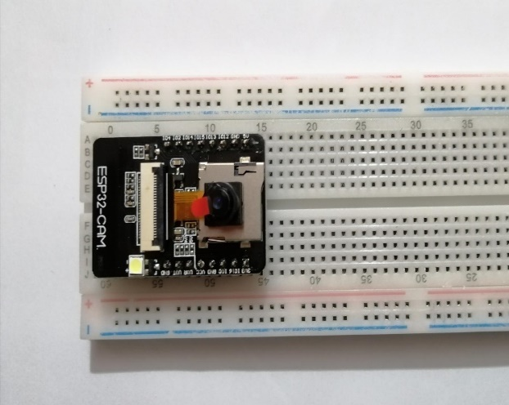

**Fig1:** ESP32 Camera  **Fig2:** Micro SD Card

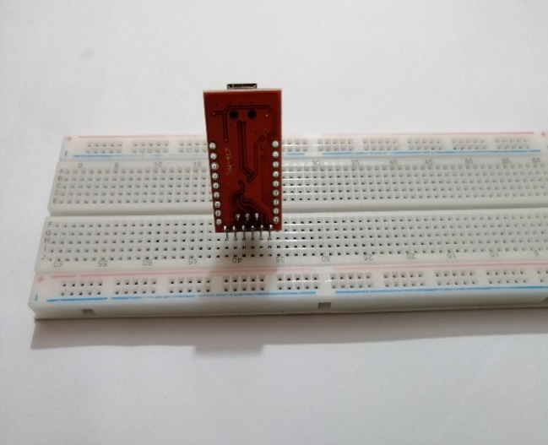

**Fig3:** FTDI Module    **Fig4:** PIR Motion Sensor

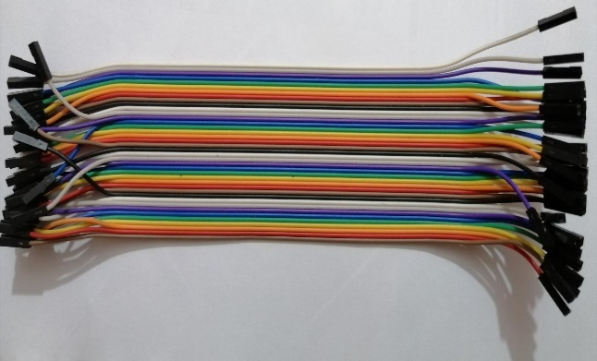 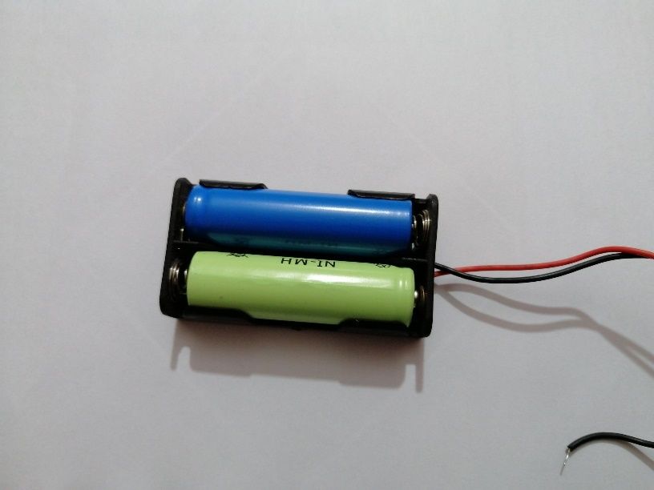

**Fig5:** Connecting Wire **Fig6:** Battery

1. **Project Implementation Description:**

Project implementation is combined with two parts. One is the Circuit Implementation, and another is the Code Implementation.  
  
**Circuit Implementation:** This project is established with some components like ESP32-CAM, FTDI module, PIR motion sensor. These are the main part of the project. First, we have connected the ESP32-CAM with the FTDI module.

Here is the connection of ESP32-CAM and FTDI module

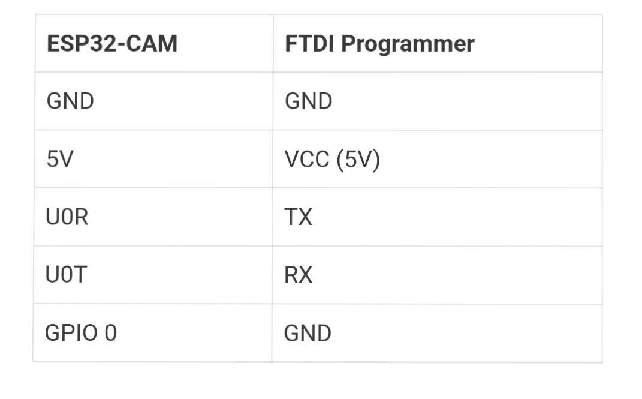  
  
Here important part is IO0 must need to connect with the GND pin and **put the ESP32-CAM module in Flash/ Boot mode** so that it is able to upload code.

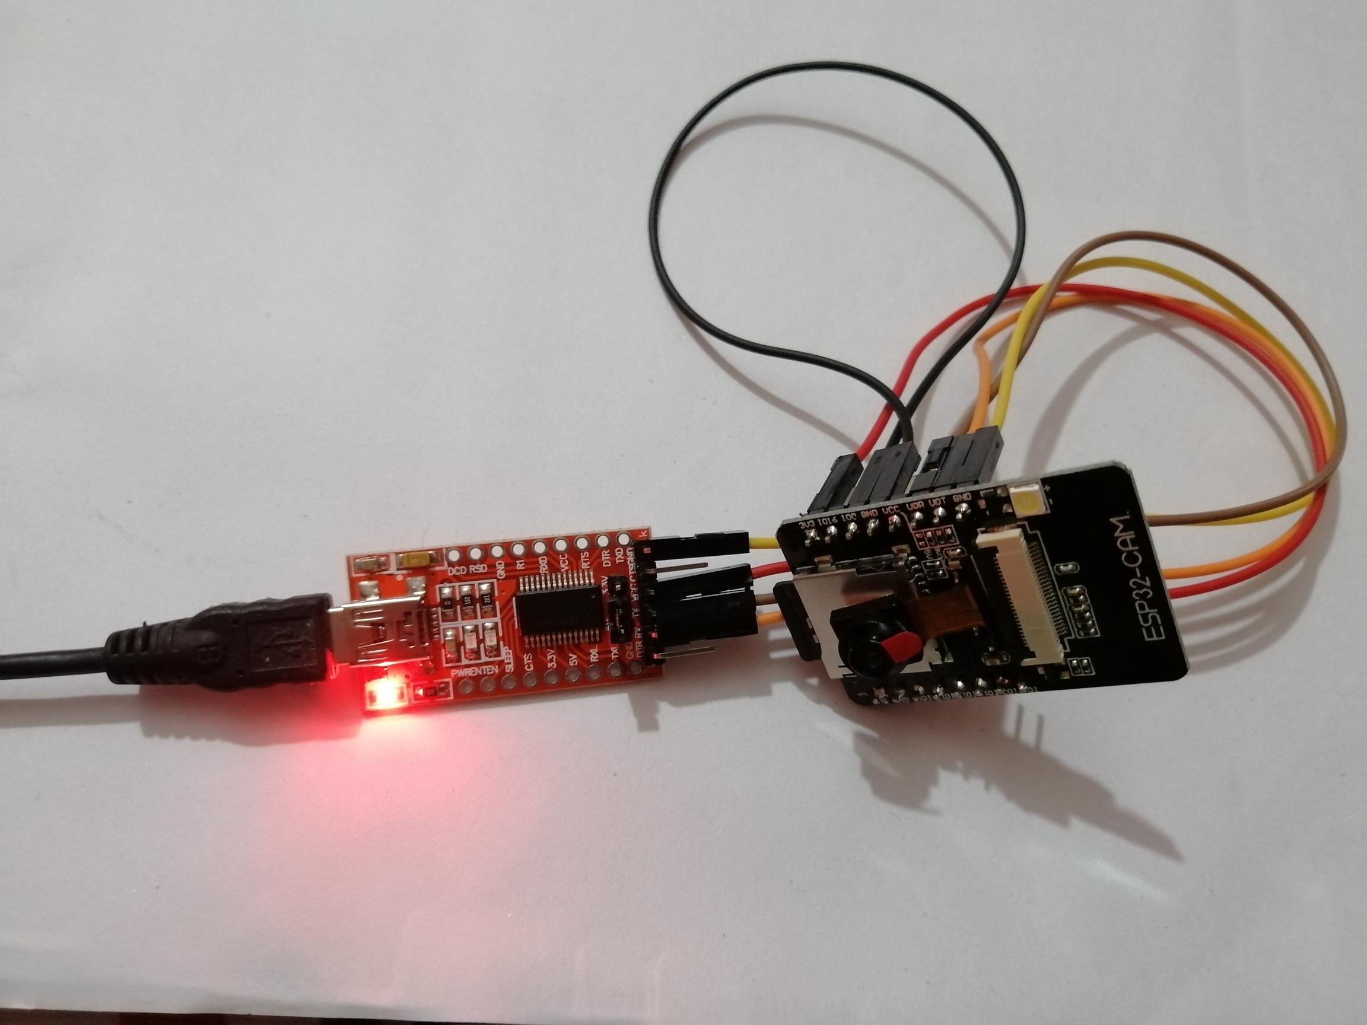

**Fig:** ESP32-CAM And FTDI MODULE Connection

After completing the implementation of FTDI MODULE and ESP32-CAM we have upload the code there with USB cable.

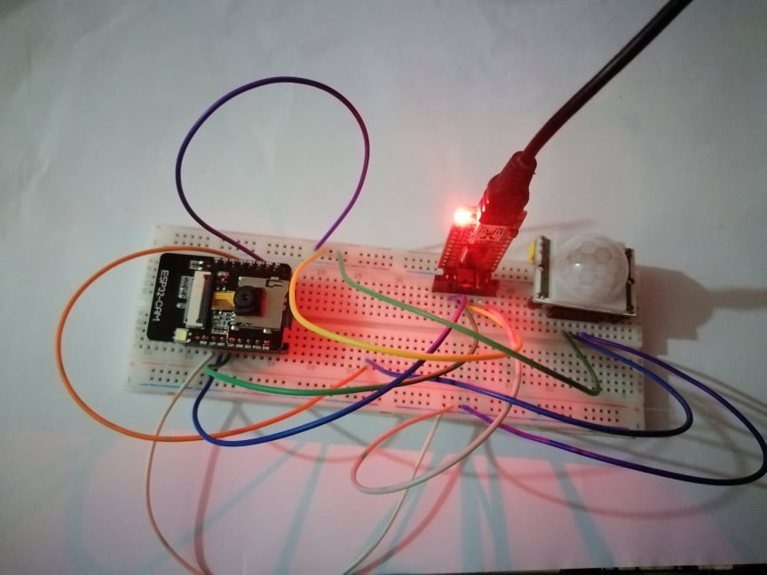

**Fig:** ESP32-CAM, PIR MOTION SENSOR And FTDI MODULE Connection

Then we have added the PIR MOTION SENSOR with this. In the pin no 13 of the ESP 32 CAM we have connected the PIR MOTION SENSOR. Then connected the VCC with the VCC of the circuit and applied the group with the circuit ground. Here is the connection,

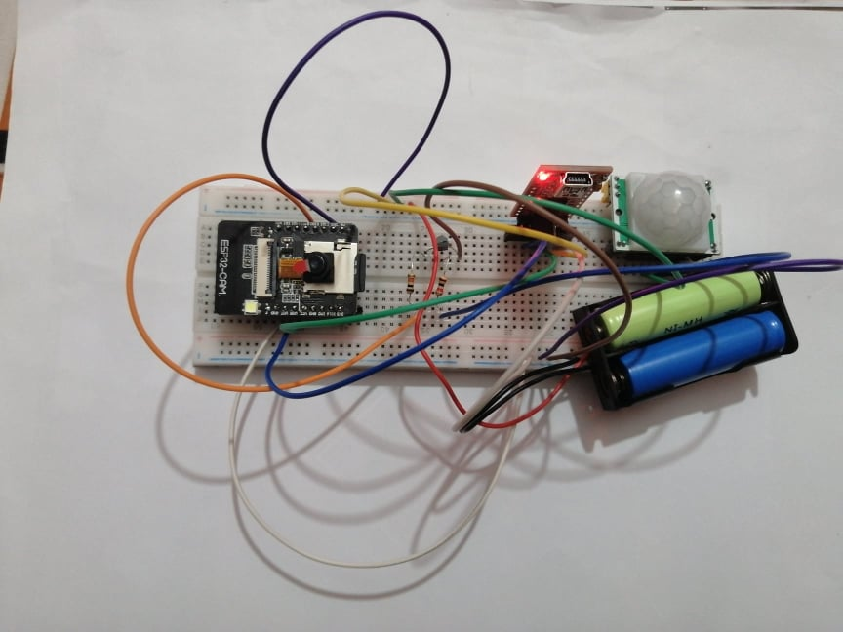

**Fig:** ESP32 CAM, PIR MOTION SENSOR, FTDI MODULE With Wired Battery Connection

Finally for the power supply we have used 5-volt battery. We have connected the red wire with the VCC and connect the black wire with the ground. Here is the final implementation of the project.

**Code implementation:** For code first, we need to download Arduino IDE 1.8.12. Then need to add some library and boards in Arduino IDE like ESP32 version 1.0.4, ArduinoJson version 6.18.3, and CDM-2.08.28-WHQL-Certified (for connecting COM port). The process will be

The Library Manager will open. Search for required libraries and install them as shown steps.

The **Boards Manager** will open. Search for required boards and install them as shown steps.

After that, need to define the Wi-Fi SSID and password. Then must include the header file. Set the ESP32-CAM 13 pin with the PIR MOTION SENSOR. We need to define image quality too. Then must input the camera configuration and finally set the delay time around 10000 and timeout is 10s. Thereafter must set serial monitor (COM) baud 115200 as like serial begin which is in the code section. Then must select right board before upload code. Being camera module is AI Thinker the board must be select AI Thinker ESP32-CAM and the programmer must be select AVR ISP. After that it is ready to upload. After successful uploading, disconnect IO0 and GND pins of ESP32-CAM then, Open Serial Monitor.

Important part here we must set connection with the telegram app. For that we need to follow some steps. It is important to set connection with telegram by inputting the chat id and token number. So, gaining that we need to follow some steps.

​Step of telegram connection.

Here is the live picture of the working procedure

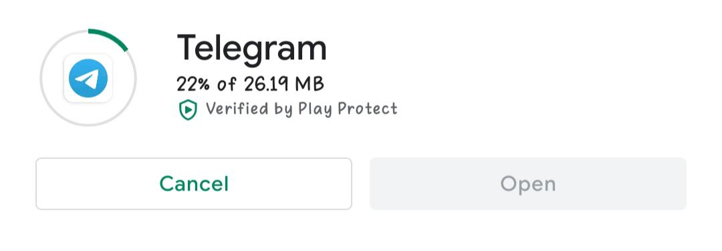

**Fig:** Download Telegram

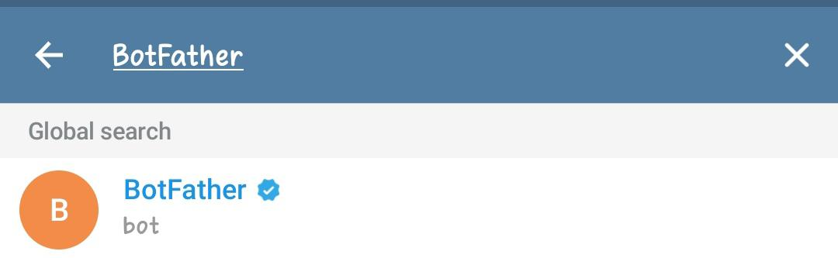

**Fig:** Search BotFather

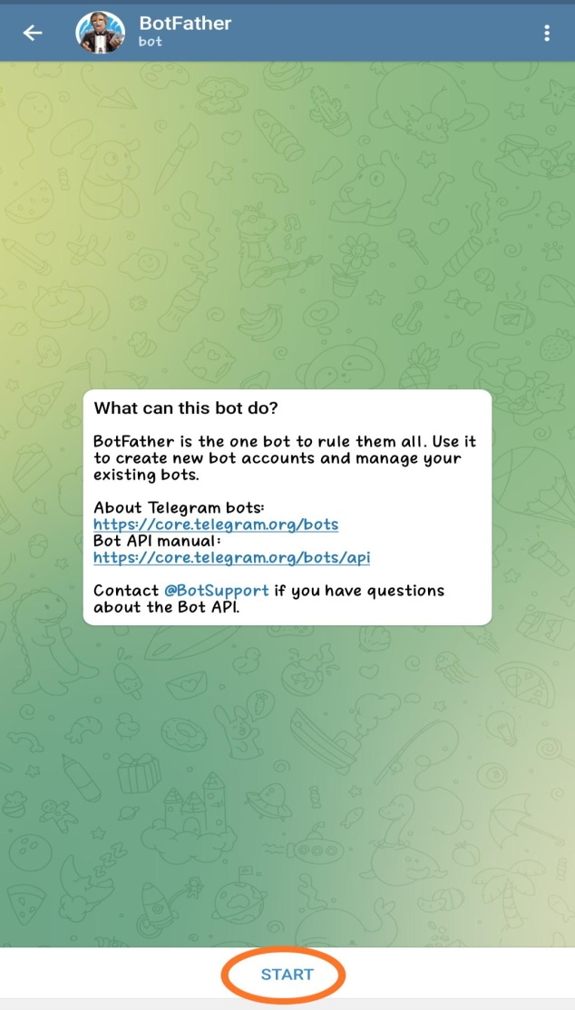 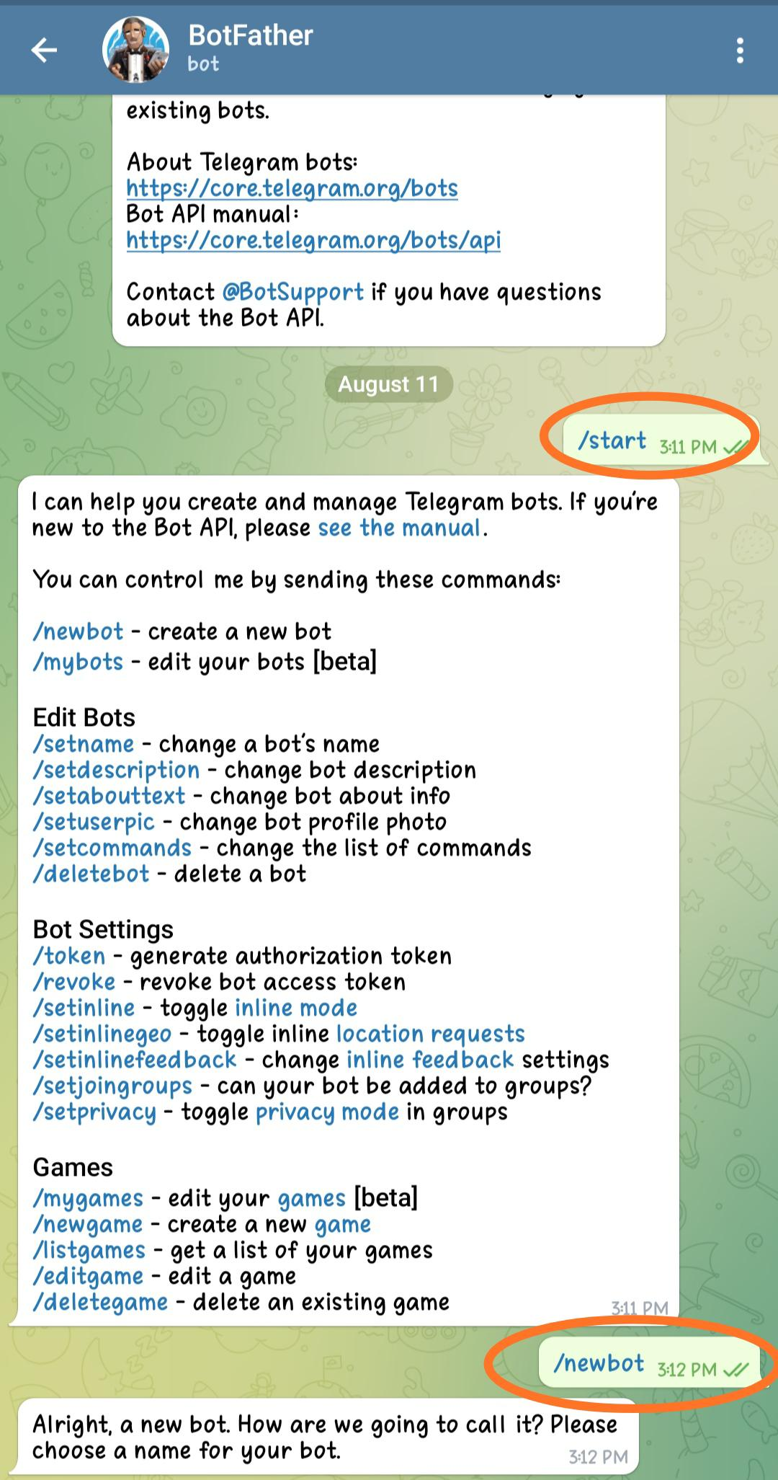

**Fig:** Start And / newbot

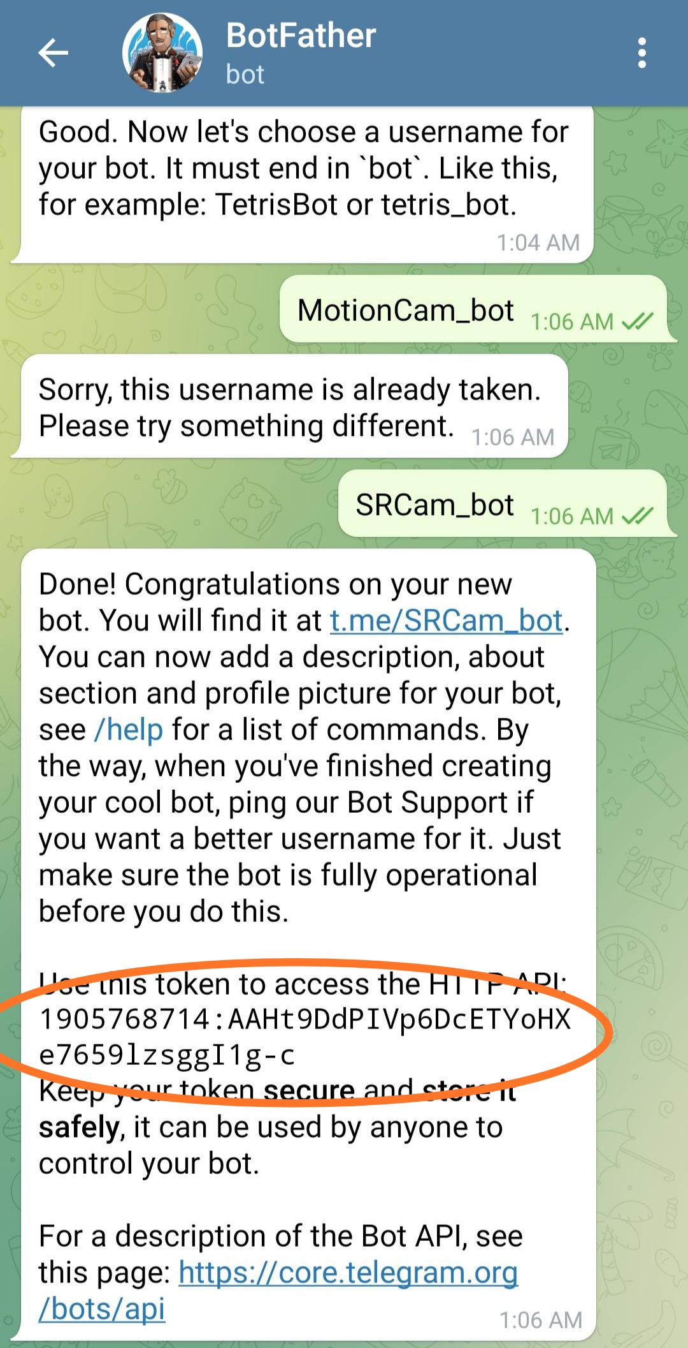

**Fig:** Chat ID And Token Number

Whenever all the settings are done successfully, open the serial monitor and we can observe that the Wi-Fi is connected, and Start IP address are shown. Then connect to API Telegram. ORG messages are seen. After that the image is sent to the users Telegram account, at this time message is shown like “ok”: true, “result” and so on then the camera went to deep sleep mode. At the same time copy of those pictures are also saved in Micro SD card also.

1. **Circuit diagram:**

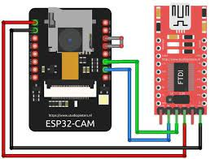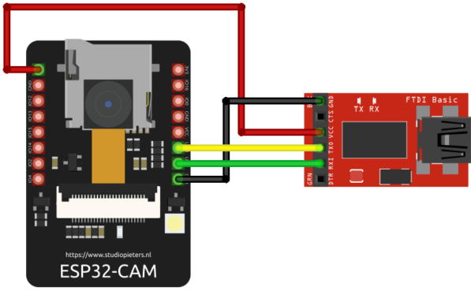

Fig: Connect with IO0 and GND ESP32-CAM Fig: Disconnect with IO0 and GND ESP32-CAM

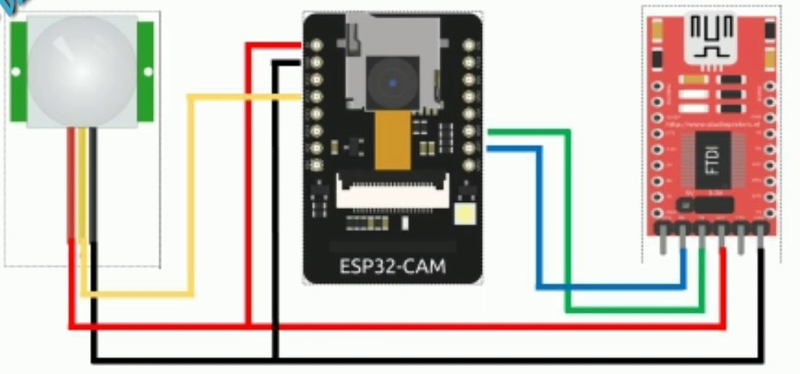

Fig: Connect with PIR MOTION, FTDI PROGRAM with ESP32-CAM

1. **Limitations:**

* Whenever the power source is disconnected from the device, it will not be working.
* As ESP32-CAM is a Wi FI control device so if there occur any Wi Fi issue it will be not working.
* If the PIR MOTION SENSOR is damage this device will be stop its working.

1. **Advantage:**

* In case the internet connection of programmed Telegram user is discontinuance for some while, but it still sends image and when the user connects with internet, he or she can see the images.
* It will store copy of the picture onboard Micro SD Card.
* Low power consumption.
* Purchase cost is also favorable.

1. **Possible Errors with solutions:**

* Do not install latest Arduino IDE and required boards or libraries. Because some time it does not support used header files. Give error during uploading code in the FTDI PROGRAM.
* Must have to connect with IO0 and GND on the ESP32-CAM during uploading code otherwise a fatal error occurred.
* Connect with 5V of both ESP32-CAM and FTDI PROGRAMMER else because of mismatch of voltage code will be not uploaded.
* Select right board for used Camera. For this project must select AI Thinker ESP32-CAM board and right port.
* Need a strong Wi Fi signal for upload code and drive the device.
* In the serial monitor if see dots (….) are printed, it means that used ESP32-CAM is not establishing a Wi Fi connection with given router password. For this reason, double check the network credentials, password and SSID.
* Select the right Baud rate in the Arduino IDE and Serial Monitor as like used in the code. Here used Baud rate is 115200 baud.
* Have to used larger Micro SD card around 8GB or 16GB otherwise it cannot store any image on onboard SD card. According to ESP32-CAM configuration it supports 2GB or 4GB Micro SD but sometimes it does not work on that is why used 8GB or 16GB card. Here used card is 8GB.
* If the error message is shown like Camera INIT failed with error 0X20001 or similar, then Camera OVX is not connected properly to the ESP32 board or the wrong pin assignment in the code. For solve that problem make sure to select right camera module for project and connect with right pin.
* The Brownout detector or Guru Meditation error seen for poor quality USB cable, USB cable is too long, bad computer USB port or not enough power provided by the computer USB port. To solve this problem at first try a different shorter USB cable, use different computer USB port, or use another USB hub with an external power supply and must have to power the ESP32-CAM with 5V.
* In case the oversight is shown like Sketch too big error wrong partition scheme selected, then make sure select the right partition scheme for solving this mistake. This time must go Tools in Arduino IDE, then partition scheme and select Huge APP (3MB NO OTA).

1. **Implemented Code:**

Here is the hole source code which we used for our project.

https://github.com/Zamanrifat/ESP32-Cam-Motion-Alert-System-For-Real-Time-Security-Monitoring-via-Telegram.

1. **Reference:**

<https://www.youtube.com/watch?v=VqfyFXZXrZ4>

<https://www.youtube.com/watch?v=5EBwC48-eqc>

<https://www.youtube.com/watch?v=OP_sRGceHN4>